IMPLEMENTING CRM FOR RESULT TRACKING OF A CANDIDATE WITH INTERNAL MARKS

1. Introduction:

1.1 Over view:

The improved features of CRM software have increased both its complexity and necessity.Nearly of CRM implementation campaigns suffer from improper preparation and misaligned objectives among internal stakeholders.A properly conceived CRM implementation strategy covers the breakdown of its goals,research strategy,development and future.This article is for small business owners who want to make sure they are taking the right step when implementing a new CRM system.

1.2 Purpose:

It is save a for time.The purpose of the project is to manage the school student’s result tracking process in the easy way.Students do not need to check the notice board and everyone will way updated this the main purpose of this project.Can work easily.Increase candidate quality.

1. Problem definition & design thinking:
   1. Empathy Map

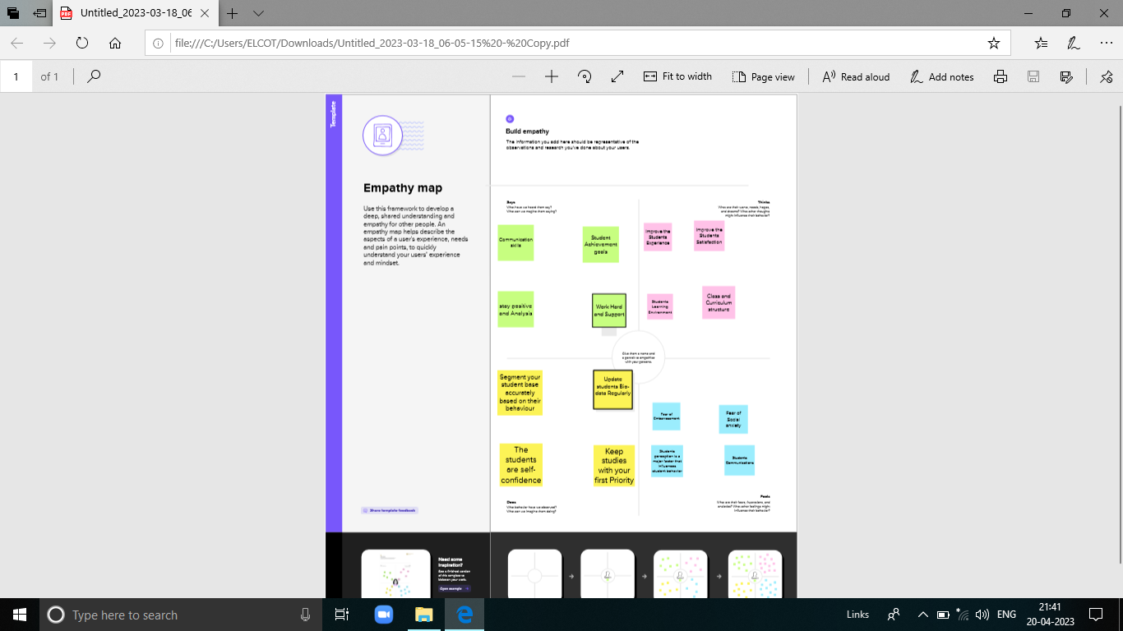

* 1. Brainstorming & Idea Prioritization Template:

Ideation:

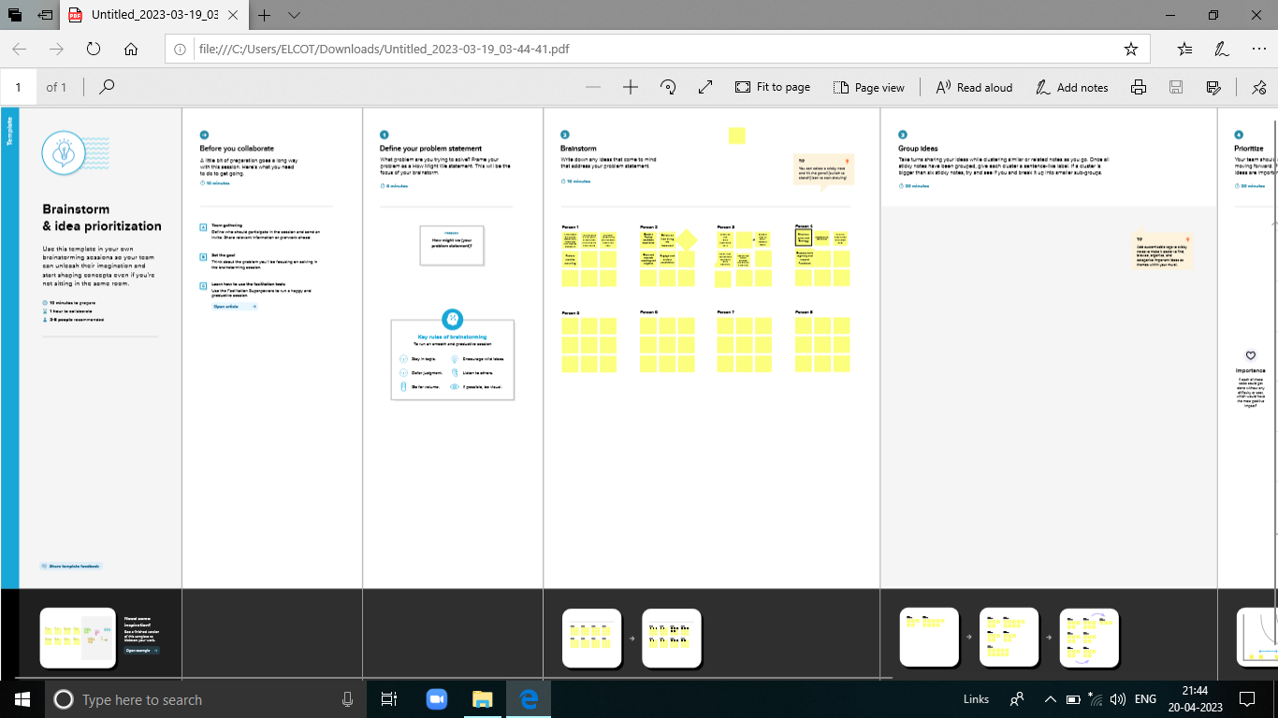

1. Result:
   1. Data Model:

|  |  |
| --- | --- |
| OBJECT NAME | FIELDS IN THE OBJECT |
| Semester | FIELD LABEL:  Semester  Semesters |
| Candidate | FIELD LABEL:  Candidate  Candidates |
| Course details | FILED LABEL:  Course  Courses |
| Lecturer details | FILED LABEL:  Lecturer  Lecturers |
| Internal results | FILED LABEL:  Internal mark  Internal marks |

* 1. Activity & Screenshot

(Milestone-2: OBJECT)

Activity-1. Creation of Semester Object

#Creation of Object for Semester Management

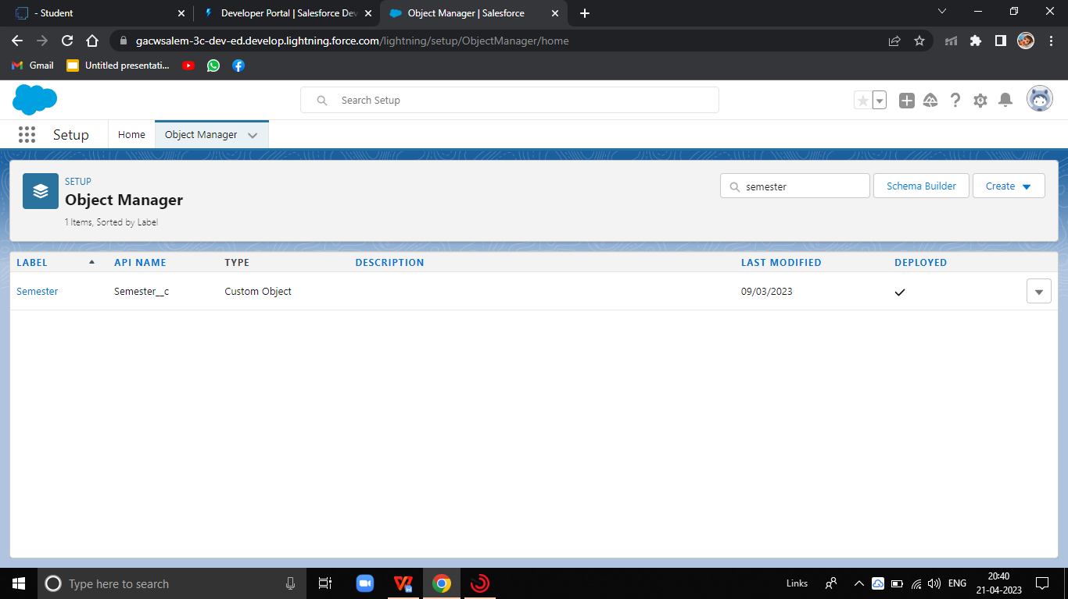

(Milestone-2:OBJECT)

Activity-2:Create Candidate Object

# Creation of Candidate Object

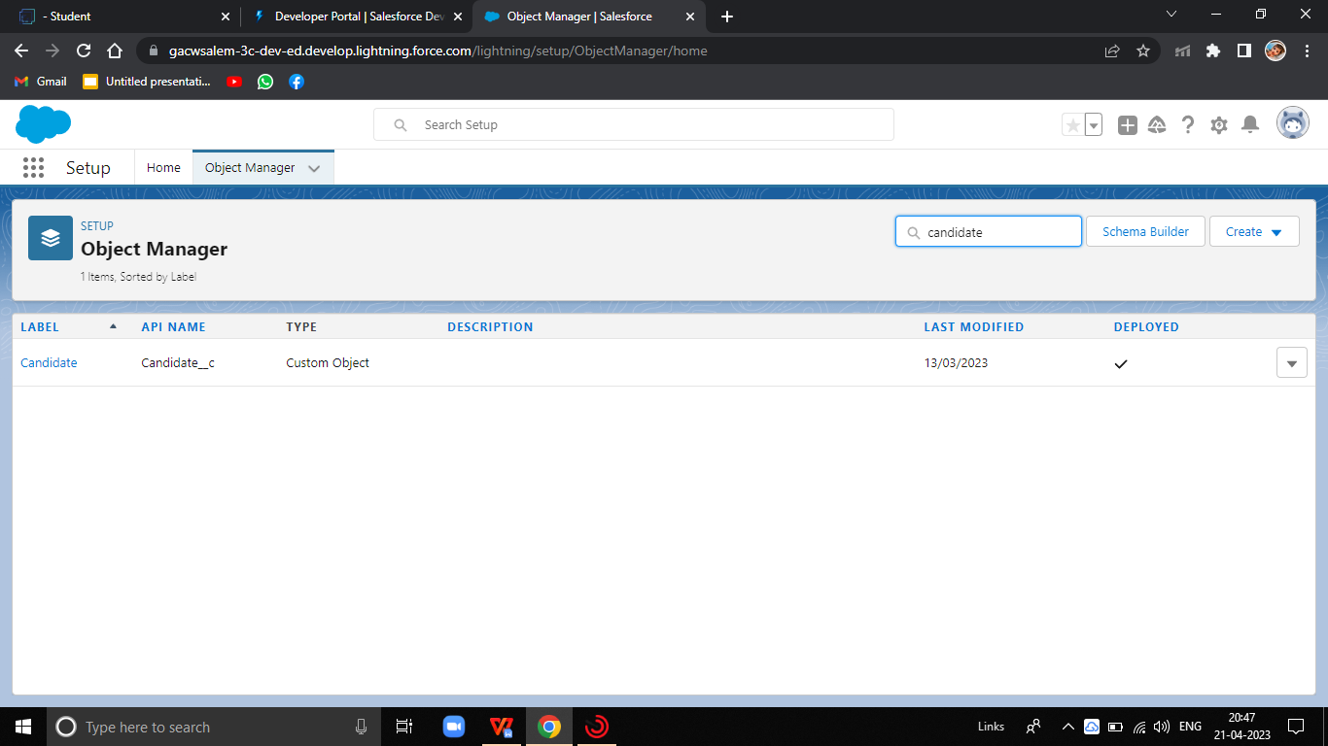

* 1. Activity -3: Create Course Object

# Creation of Course Object

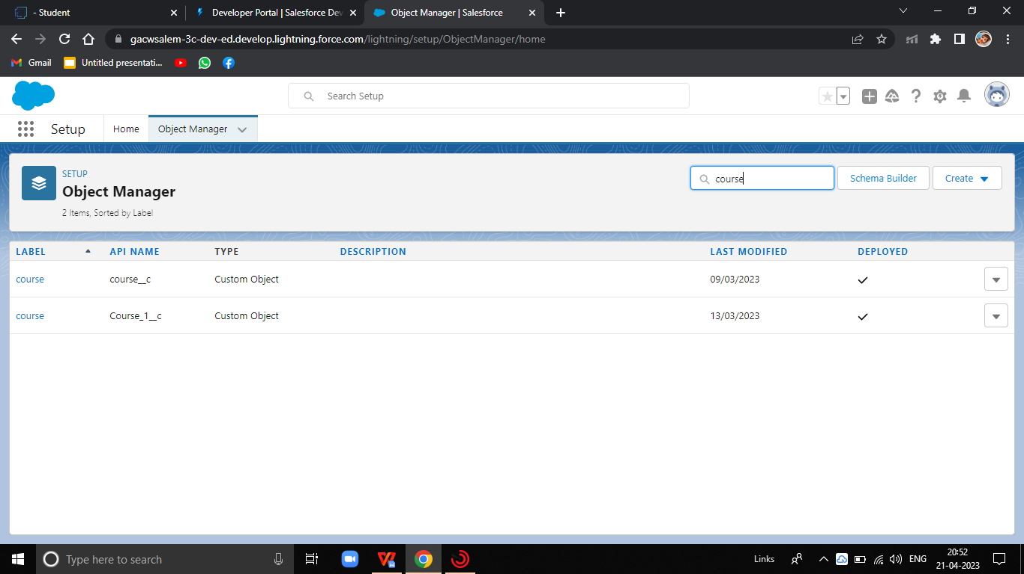

* 1. Activity -4: Create Lecturer Object

# Creation of Lecturer Object

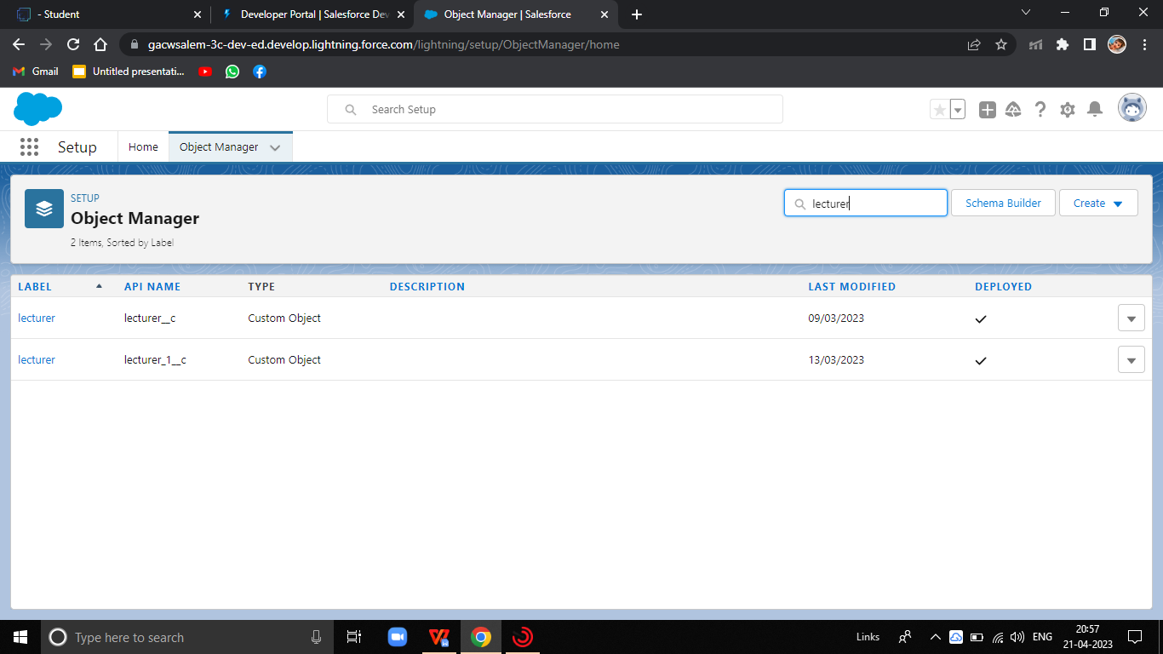

* 1. Activity-5: Create Internal Object

# Creation of Internal Object

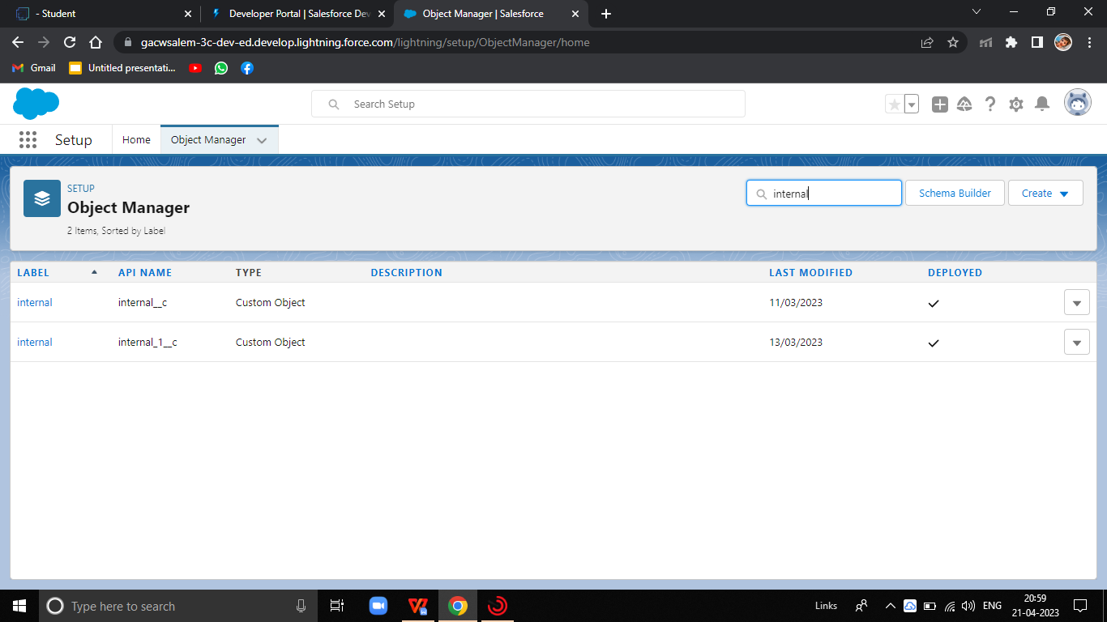

(Milestone-3: FILEDS & RELATIONSHIP)

Activity-1: Creation of the fields for the Semester Object

# Creation of fields for the Semester Object

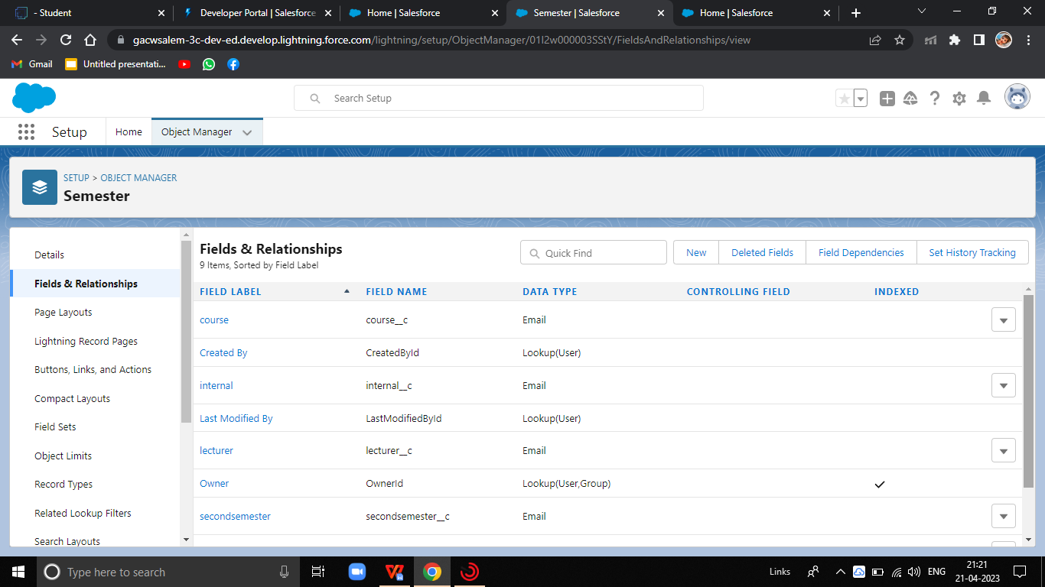

(Milesone-3: FIELDS & RELATIONSHIP)

Activity-2: Creation of the fields for the Candidate Object

# Creation of fields for the Candidate Object

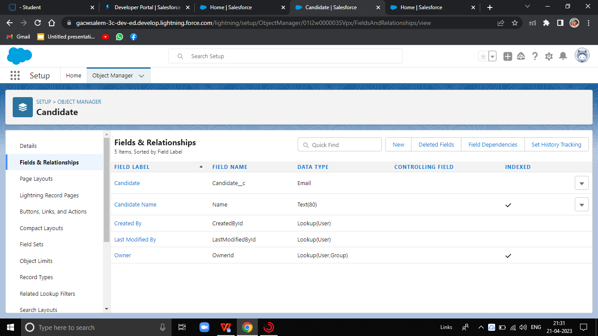

(Milestone-3: FIELDS & RELATIONSHIP)

Activity-3: Creation of the fields for the Course Object

# Creation of the fields for the Course Object

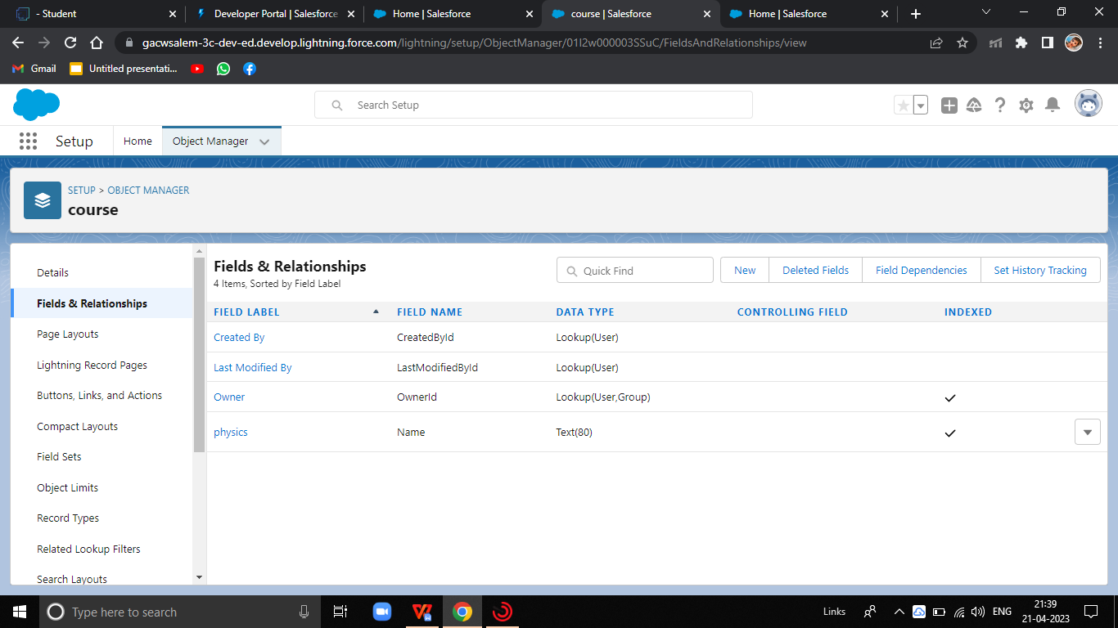

(Milestone-3: FIELDS & RELAIONSHIP)

Activity-4: Creation of the fields for the Lecturer Object

# Creation of the fields for the Lecturer Object

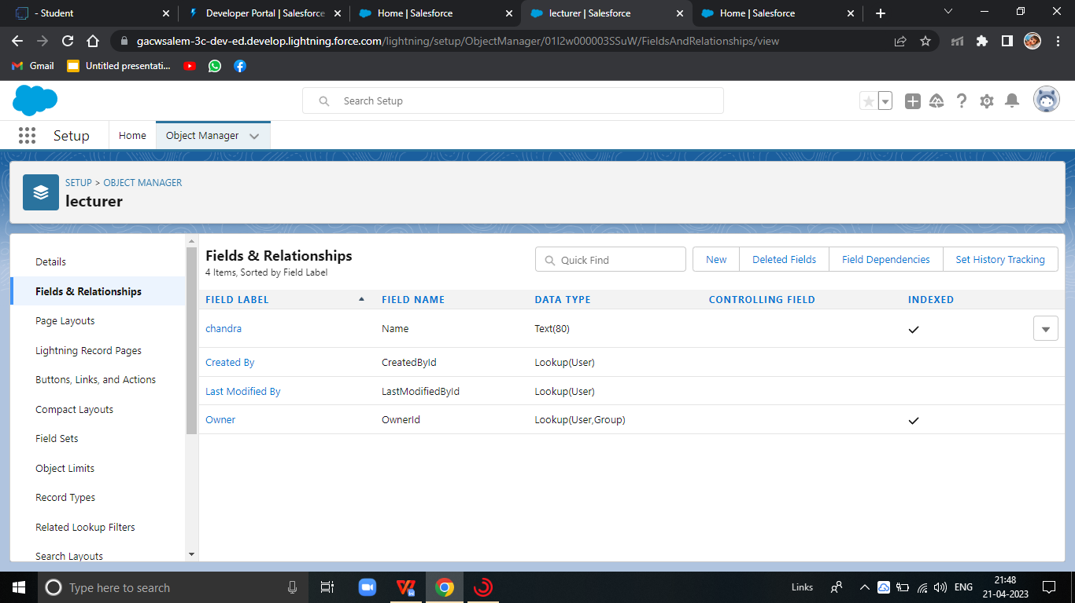

(Milestone-3: FIELDS & RELATIONSHIP)

Activity-5: Creation of the fields for the Internal Object

# Creation of the fields for the Internal Object

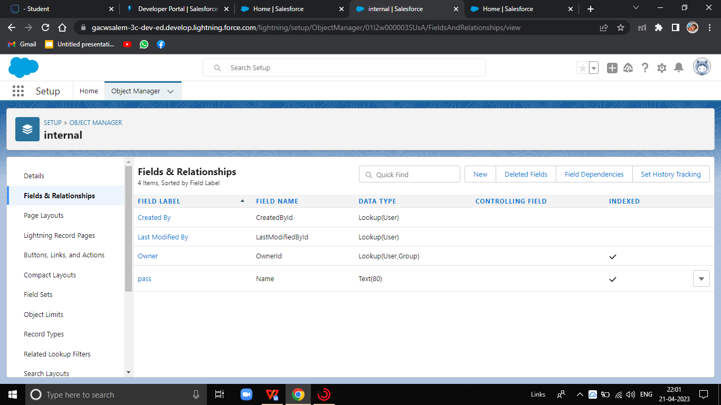

(Milestone-4: USERS)

Activity-1: Creating a Users

# Creating a Users

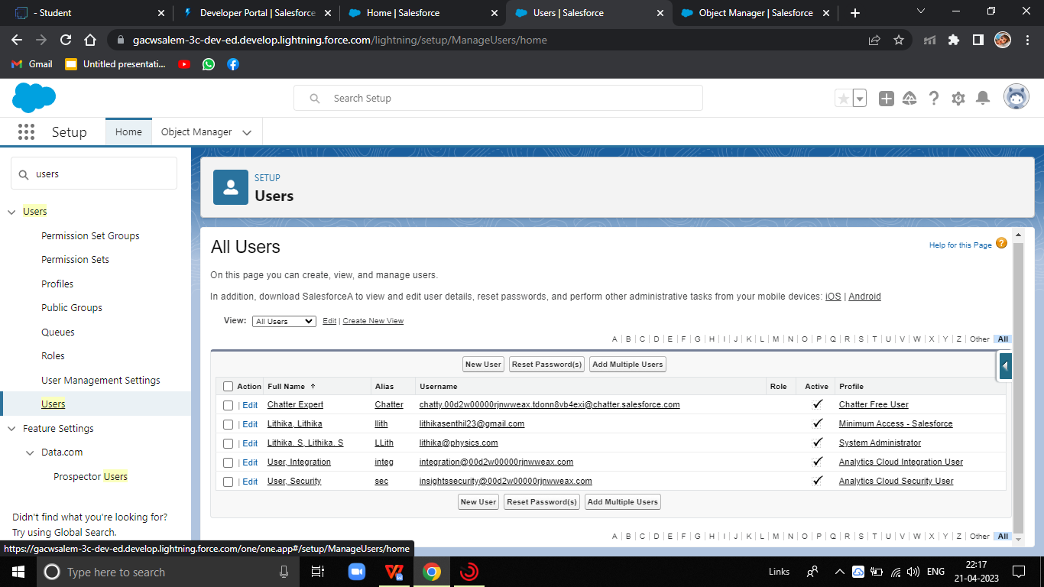

(Milestone-5: REPORTS)

# Reports

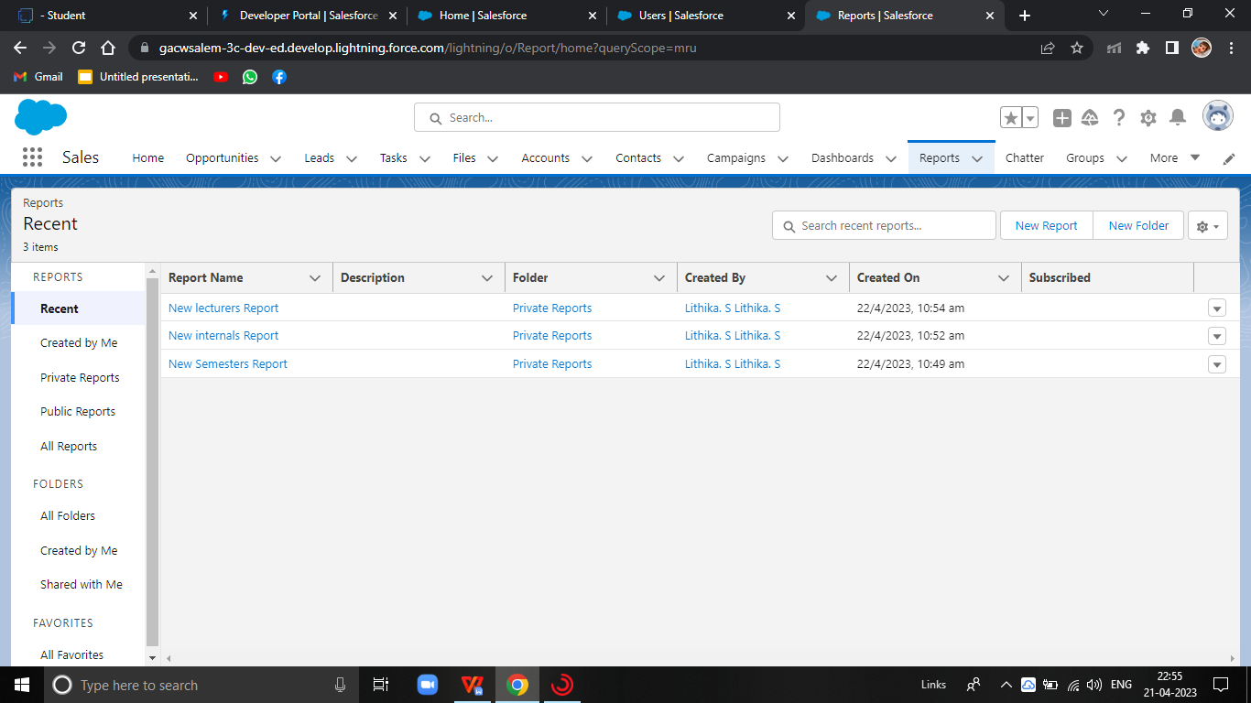

1. TRAILHEAD PROFILE PUBLIC URL:

TEAM LEAD - <https://trailblazer.me/id/llithikas>

Team Member 1 -<https://trailblazer.me/id/priyabalakrishnan2003>

Team Member 2- <https://trailblazer.me/id/pnandhini6>

Team Member 3- <https://trailblazer.me/id/niibscphysicstm>

1. ADVANTAGES & DISADVANTAGES

(ADVANTAGES)

1. It allows for the consolidation of customer data and the basis for deep insights.
2. It speeds up the sales conversion process.
3. It increases staff productivity , lowering time-cost.
4. Improves customer experience by allowing rationalization

and improved query resolution.

(DISADVANTAGES)

1. Customer experience may worsen due to staff over-reliance on the system.
2. Security and data protection issues with centralized data.
3. Requires a process-driven sales organization.
4. CRM may not suit all business.

6.APPLICATIONS

1. I want something reliable.
2. Target marketing.
3. Increase candidate quality.
4. Can work easily.

7.CONCLUSION

Student Internal Mark Management System deals with student details,academic related reports,college details and course details.It tracks all the details of a student from the day one to the end of his course which can be used for all reporting purpose ,tracking of progress in the course,completed semester ,upcoming semester details,project or any other assignment details,and final exam result.

1. FUTURE SCOPE

Scope of education means range of view ,outlook,field or opportunity of activity ,operation and applications of education.Education has a wider meaning and application.

THANK YOU